**Department of Computer Science & Engineering**

**International Islamic University Chittagong**



**A Project Proposal on**

**[Online Second Hand Book Shop]**

**Supervised by**

Ahmed Shan-A-Alahi

Lecturer

Dept of CSE, IIUC.

**Submitted by**

Name: Sanjida Akter

ID: C161290

**TABLE OF CONTENTS**

**CHAPTER 1: INTRODUCTION……………………………………………… 7**

* 1. Introduction………………………………………………………………... 7
  2. Motivation…………………………………………………………………. 7
  3. Existing App ……………………………………………………………… 8
  4. Objective of Online Second Hand Book Shop …………………………... 9

**CHAPTER 2: METHODOLOGY……………………………………………. 10**

* 1. Process Model…………………………………………………………….. 10
  2. Recent trends in Software Process Model ……………………………….. 10
  3. A particular Process model for “Online Second Hand Book Shop”…….... 11

2.3.1 Requirement Specification……………………………………….. 14

2.3.2 Why Requirement Specification is needed? .................................. 14

* 1. Requirement Definition........................................................................... 14

2.4.1 Requirement Specification of “Online Second Hand Book Shop”.. 16

2.4.2 User list of Online Second Hand Book Shop…………………….. 17

* 1. Requirement Validation…………………………………………………. 16

2.5.1 Requirement Validation in software process……………………… 17

2.5.2 Requirement Validation in software process ………………………………… 18

2.6Service and data input……………………………………………………. 18

2.7Tools……………………………………………………………………... 19

2.8 Feasibility study…………………………………………………………... 20

2.8.1 Feasibility Study of Online Second Hand Book Shop…………….. 21

2.9 Gantt Chart……………………………………………………………….. 21

2.10 Objectives/Goals of the System………………………………………….. 22

2.11 Testing…………………………………………………………………… 23

**CHAPTER 3: SYSTEM ANALYSIS………………………………………. 27**

3.1 Proposed Methodology ……………………………………………………. 27

3.2 System overview of Online Second Hand Book Shop……………………. 28

3.2.1 Data overview ……………………………………………………….. 29

3.3 Security……………………………………………………………………... 29

3.4 Version support…………………………………………………………….. 29

3.5 System Design……………………………………………………………… 29

3.6 A general Model of software design process………………………………. 30

3.7 Flow Chart ………………………………………………………………… 31

3.7.1 Flow Chart for Admin………………………………………………. 32

3.7.2 Flow Chart for Seller………………………………………………... 32

3.7.3 Flow Chart for Customer……………………………………………. 33

3.8 Use case Diagram…………………………………………………………… 33

3.8.1 Use Case Diagram for Admin…………………………………………. 34

3.8.2 Use Case Diagram for Seller…………………………………………... 34

3.8.3 Use Case Diagram for Customer………………………………………. 35

3.9 Entity Relationship Diagram of Online Second Hand Book Shop…………... 36

3.10 Database Table of Online Exam Management System…………………….. 37

3.11 Data flow Diagram………………………………………………………… 41

3.11.1 Level 0 DFD……………………………………………………….. 42

3.11.2 Level 1 DFD for Admin…………………………………………… 43

3.11.3 Level 1 DFD for Seller…………………………………………….. 44

3.11.4 Level 1 DFD for Customer……………………………………….... 45

3.12 Activity diagram…………………………………………………………... 46

3.12.1 Activity Diagram of Admin……………………………………….. 47

3.12.2 Activity Diagram of Seller………………………………………… 48

3.12.3 Activity Diagram of customer……………………………………... 49

**CHAPTER 4: DESIGN AND IMPLEMENTATION…………………….. 50**

4.1 Overview……………………………………………………………………. 50

4.2 Design Model……………………………………………………………….. 50

4.3 Graphical Representation………………………………………………….... 51

* + 1. Web Application………………………………………………………. 51

Customer Panel……………………………………………………. 51

Admin panel………………………………………………………. 58

Seller Panel……………………………………………………….. 61

**CHAPTER 5: CONCLUSION………………………………………………... 68**

5.1 Limitations………………………………………………………………….. 68

5.2 Future work………………………………………………………………… 68

5.3 Conclusion………………………………………………………………….. 68

**References……………………………………………………………………….. 70**

**TABLE OF FIGURES**

**Figure 2.1: Spiral model Process………………………………………………………….. 11**

**Figure 2.2: design validation process of Online Second Hand Book Shop……………... 18**

**Figure 2.3: Gantt chart…………………………………………………………………….. 22**

**Figure 3.1: System Overview of Online Second Hand Book Shop……………………… 28**

**Figure 3.2: A general Model of software design process………………………………… 30**

**Figure 3.3: Flow Chart for Admin………………………………………………………... 31**

**Figure 3.4: Flow Chart for seller………………………………………………………….. 32**

**Figure 3.5: Flow Chart for Customer…………………………………………………….. 33**

**Figure 3.6: Use Case Diagram for Admin………………………………………………... 34**

**Figure 3.7: Use Case Diagram for Seller ……………………………………………….... 35**

**Figure 3.8: Use Case Diagram for Customer…………………………………………….. 36**

**Figure 3.9: ER Diagram for Online Second Hand Book Shopping…………………….. 36**

**Figure 3.10: Database table of Admin……………………………………………………. 37**

**Figure 3.11: Database table of Seller……………………………………………………... 38**

**Figure 3.12: Database table of Customer……………………………………………….... 38**

**Figure 3.12: Database table of Customer………………………………………………… 39**

**Figure 3.14: Database table of Subcategory…………………………………………….... 39**

**Figure 3.15: Database table of Book…………………………………………………….... 40**

**Figure 3.16: Database table of Book Review……………………………………………... 40**

**Figure 3.17: Database table of Wish list………………………………………………….. 41**

**Figure 3.18: Level 0 DFD for Second Hand Online Book……………………………….. 42**

**Figure 3.19: Level 1 DFD for Admin……………………………………………………... 43**

**Figure 3.20: Level 1 DFD for Seller………………………………………………………...44**

**Figure 3.21: Level 0 DFD for Customer………………………………………………….. 45**

**Figure 3.22: Admin Activity Diagram……………………………………………………. 47**

**Figure 3.23: Seller Activity Diagram……………………………………………………... 48**

**Figure 3.24: Customer Activity Diagram…………………………………………………49**

**Figure 4.1 Design Model…………………………………………………………………....50**

**Figure 4.2: Homepage Screen of website………………………………………………….51**

**Figure 4.3: Book Category and Book details of website………………………………….52**

**Figure 4.4: Customer Rating System……………………………………………………...53**

**Figure 4.5: Customer wish list……………………………………………………………..53**

**Figure 4.6: Customer login of website…………………………………………………….55**

**Figure 4.7: customer Order panel of website……………………………………………..55**

**Figure 4.8: payment system of website…………………………………………………... 57**

**Figure 4.9: Admin login panel of website………………………………..………………. 58**

**Figure 4.10: Admin panel of website…………………………………………………….. 59**

**Figure 4.11: Manage book or product by Admin……………………………………….. 60**

**Figure 4.12: Admin insert book………………………………………………………….. 61**

**Figure 4.13: Manage seller by Admin……………………………………………………. 62**

**Figure 4.14: Admin manage user………………………………………………………… 63**

**Figure 4.15: Seller register panel………………………………………………………… 64**

**Figure 4.16: Seller login panel……………………………………………………………. 65**

**Figure 4.17: Seller panel…………………………………………………………………... 66**

**Figure 4.18: Seller Insert Book…………………………………………………………… 67**

CHAPTER 1

**INTRODUCTION**

* 1. **Introduction**

**Online Second Hand Book Shop** is basically web based online shopping. The internet represents a very important role in today’s community. Students have many course based literature text books that they have confined reading and these books are put down on their book shelves unutilized. These books can be sold and the continue can be used to buy another book the student present needs. The website will not only serve students but also serve the entire commonwealth or anybody who wants to buy second hand books or wants to unoccupied their book shelves and get financial support from it. These books can simply be uploaded to the website and another student or person can have access to buy the book by just visiting the website. Students also have part time incomes balanced to the remainder of the working population. Hence any reasonable resource for getting income is always welcomed.

* 1. **Motivation**

The motivation that works behind the project is to provide wide range of books to the people of lower income group. Students who do not have the capacity to buy academic and other books can easily access into to this website and have their necessary information. It also gives the customer a hustle free shopping. Sometimes not all the books are available all the time. But with the help of this website a huge collection of books is available all the time. The payment system is easy and convenient. Beside this it will also works as archives of old valuable books. Basically this is a online library. The rating system link of this website gives the reader a preview of a book which helps them to judge a book before they purchase. It also creates a rapport between the author and the reader. We know that printing a book consumes paper which also leads to cutting of trees and environment pollution.

* 1. **Existing App**

There might have many website related to this topic but the project we are doing is slightly different in a new innovative idea.

Here, we tried to discuss about the existing system in Bangladesh and also show the limitation and solution which have been solved in our online book shop system.

∎ **Bikroy.com**

**Advantages of Bikroy.com:**

**•** This apps are easy to use

**•** Convenient shopping

• One stops shopping

**Limitation of Bikroy.com:**

• Membership required to buying books

• Sales everything not only second hand books

• Payment system based direct contact

∎ **Rokomari.com**

**Advantages of Rokomari.com:**

**•** This apps are easy to use

**•** Convenient shopping

• Only sales books

**Limitation of Rokomari.com:**

• Authority is the main seller

• There is no multi seller option

**1.4 Objective of Online Second Hand Book Shop**

The project objectives are:

* To make the shopping easier and comfortable
* To provide multi seller facility
* To provide demo book reading
* To provide comment section that users gives book review
* To serve the customers without wasting their valuable time
* To reach the products to the customer’s address with great Care
* To represent as a compete e-commerce site of Bangladesh

CHAPTER 2

**METHODOLOGY**

Methodology is a lot of practices. This term might be utilized to allude to rehearses which are broadly utilized over an industry or logical order, the procedures utilized in a specific research study, or the strategies used to achieve a specific task. Individuals may likewise utilize the expression "methodology" to allude to the investigation of such strategies, as opposed to the techniques themselves.

A methodology can be considered to incorporate numerous strategies, each as applied to different features of the entire extent of the philosophy. The exploration can be separated between two sections; they are subjective research and quantitative research. The Project Management Methodology empowers the conveyance association to handle these undertakings exhaustively, systematically, and in an incorporated way for adequate hazard. Along these lines, it gives benefits at the key, strategic and operational levels.

**2.1 Process Model**

Procedure is a movement, which works on an article and changes its state. Model is the graphical portrayal of an article. In this way, a procedure model shows the exercises of programming graphically. We need procedure model since procedure is significant than item (software). On the off chance that the procedure is great, the item likewise is great.

* 1. **Recent trends in Software Process Model**

1. Waterfall model

2. Incremental Model

3. Spiral Model

4. Prototyping:

a) Throw away prototyping process model.

b) Evolutionary prototyping process model.

**2.3 A particular Process model for “Online Second Hand Book Shop”**

While developing the “**Online Second Hand Book Shop**”, we have followed Spiral model,

**What is Spiral model?**

The spiral model combines the idea of iterative development with the systematic, controlled aspects of the waterfall model. This Spiral model is a combination of iterative development process model and sequential linear development model i.e. the waterfall model with a very high emphasis on risk analysis. It allows incremental releases of the product or incremental refinement through each iteration around the spiral.

**Phases in Spiral model-**

• Requirement Analysis

• Design

• Coding (construct or build)

• Evaluation and Risk Analysis

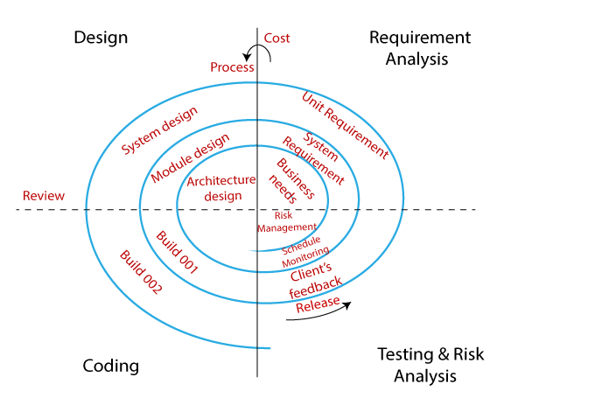

**Figure 2.1: Spiral model Process**

**Requirements Analysis:** The spiral model process starts with collecting business needs. In this, the following spirals will include the documentation of system requirements, unit requirements, and the subsystem needs. In this stage, we can easily understand the system requirements because the business analyst and the client have constant communication. And once the cycle is completed, the application will be deployed in the market.

**Design:** The second stage of the spiral model is designed, where we will plan the logical design, architectural design, flow charts, decision tree, and so on.

**Coding (construct and design):** After the compilation of the design stage, we will move to our next step, which is the coding stage. In this, we will develop the product based on the client's requirement and getting the client's feedback as well. This stage refers to the construction of the real application in every cycle.

And those spirals had an excellent clarity of the requirements, and the design details of an application are known as the build with having version numbers. After that, these builds are transferred to the client for their responses.

**Testing and Risk Analysis:** Once the development is completed successfully, we will test the build at the end of the first cycle and also analyze the risk of the software on the different aspects such as managing risks, detecting, and observing the technical feasibility. And after that, the client will test the application and give feedback.

We Prefer Waterfall model, because of its following advantages: -

• Flexible changes are allowed in spiral model.

• The development can be distributed into smaller parts.

• The customer can use the application at an early stage also.

• More clarity for Developers and Test engineers

• It will provide the wide use of prototypes.

**Limitation of Spiral model:**

**•** It is not suitable for the small and low-risk product because it could be costly for a smaller project.

**•** It is a traditional model, and thus developers only did the testing job as well.

**•** There is no requirement of review process and no parallel deliverables allowed in the spiral model.

**•** In the spiral model, management is a bit difficult; that's why it is a complex process.

**•** The maximum number of intermediate phases needs unnecessary paperwork.

**When Spiral model should be followed:**

* When there is a budget constraint and risk evaluation is important.
* For medium to high-risk projects.
* Long-term project commitment because of potential changes to economic priorities as the requirements change with time.
* Customer is not sure of their requirements which are usually the case.
* Requirements are complex and need evaluation to get clarity.
* New product line which should be released in phases to get enough customer feedback.
* Significant changes are expected in the product during the development cycle.

**2.3.1 Requirement Specification**

A specification can be viewed as a contract between users and software developers, which defines the desired (functional/service) of the software artifacts [and other properties] of its performance, reliability etc. (non-functional) without showing how much functionality is going to be achieved.

**2.3.2 Why Requirement Specification is needed?**

Requirement Specifications needed because: -

1. It is more precise description of the system functionality and the constraints on its operation.

2. It can be seen as a basis for contracts between the system developer and customers.

**2.4. Requirement Definition**

Requirement definition provides a detailed and accurate description of the needs of the user, together with a prioritization of those needs. Here feasibility and early system description are used as input. Through the output we get the system user, statement of requirement and system scope.

**2.4.1 Requirement Specification of “Online Second Hand Book Shop”**

**Functional Requirements:**

• **Enter books user want to buy** When user presses return button, the requirement will send to the server, and the server will then check the database to see if they are available or not.

• **Enter books user wants to sell** When user presses return button, the requirement will send to the server, and the server will then check the database to see if they are available or not.

**• Run Queries on books** if there are matches for the books that a buyer wants, the buyer will be notified via the browser and given the sellers’ contact information.

**• Enter information for books not in database** When a search for a book turns up nothing, the user will be asked to enter the book title and the author name so future user’s won’t have to enter the same information

**• Display query results** If the books are available, the browser will display a list of available books and the corresponding book name, ISBN, price, and owner’s email address. A checkbox next to each book allows the user a final chance to back away from purchasing.

If there are no books available in the database, a message is displayed.

**• Provide user with book owner’s contact information** the book owner’s email address is displayed as part of the query result. The buyer can contact with the book owner about delivery etc. after buying the book.

**Security Requirements**

Security systems need database storage just like many other applications. However, the special requirements of the security market mean that vendors must choose their database partner carefully.

**Software Quality Attributes**

**Availability**: The flight should be available on the specified date and specified time as many customers are doing advance reservations.

**Correctness**: The flight should reach start from correct start terminal and should reach the correct destination.

**Maintainability**: The administrators and flight in chargers should maintain correct schedules of flights.

**Usability**: The flight schedules should satisfy a maximum number of customers’ needs

**2.4.2 User list of Online Second Hand Book Shop**

There are 3 types of user in Online Second Hand Book Shop. They are:

• Administrator/Admin

• Seller

• Customer

**Administrator/Admin:**

Orders are stored in a database. The Administrator of their website can delete and refuse access to any user. He sees all the orders of the website and is in charge of managing the website. He makes sure that the seller and buyer fulfill their part of service before crediting the sellers account. The administrator will have all the rights to create, delete and update the databases. The admin will have an interface to the product table and will have another interface to manage orders and see the status of each order. He will be able login into the membership table and manage members and also send mails to them updating them on different types of information. Information of each user is stored after an order is made .So to get the history of the past orders. The order and product database is queried to get the details of the past order and sorted by the last order they made. After a sale process the parties involved in the process can give feedback to each other .This feedback that will be public on the website.

**Seller:**

Everybody need books or has a book or wants to buy a book. This website focuses the facility to selling their unused books in reasonable price and unoccupied their book shelves and get financial support from it. But they need to registration first. After registration they can login to seller panel and sells the book in this website. But sellers do not have any right to change the website modification. They can only sell the book and economical support.

**Customer:**

Customer can use this website without any condition. But they need to registration first. After registration they can login to purchase any book through required information. They can also update their profile information. If user has any complain or suggestion they can contact with the admin/administrator. The user interface should be easily understood and operated by customer.

* 1. **Requirement Validation**

Requirement validation is concerned with showing that the requirements actually define the system, which the customer wants. It has much in common with analysis as it is concerned with finding problems with the requirements. However, they are distinct processes since validation should be concerned with a complete draft of the requirements document whereas analysis involves working with incomplete requirements.

**2.5.1 Requirement Validation in software process**

During the processing period of software, different types of checks must be carried out on the requirements in the requirements document. These checks include-

**1. Validity check:** A user may think that a system is needed to perform certain functions. However, further thought and analysis may identify additional or different functions that are required. For example, in the **“Online Second Hand Book Shop”**, the system has diverse users with different needs and requirements. However, the software must be arranged in such a way that the services are provided across the user community by maintaining and checking validity.

**2. Consistency check:** Requirements in the document should not conflict. For example, in the **“Online Second Hand Book Shop”**, when we will deal with unregistered members, there should not be contradictory constraints or different descriptions of the same system function.

**3. Completeness check:** The requirement document should include requirements, which define all functions and constraints intended by the system user.

**4. Realism check:** Using knowledge of existing technology, the requirements should be checked to ensure that they could actually be implemented.

**2.5.1 Requirement Validation in software process**

Online Second Hand Book Shop is validated. We validate our App with user requirements until it satisfies the needs. The image below represents design validation process-

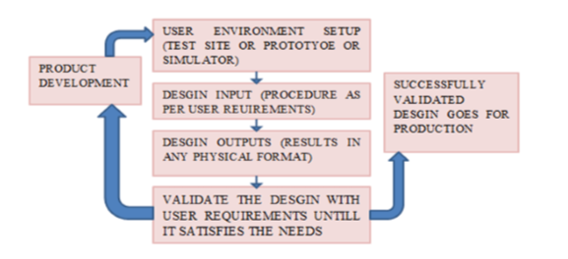

**Figure 2.2: design validation process of Online Second Hand Book Shop**

* 1. **Service and data input**
* Customer can give their rating based on book.
* Admin has the power to access the whole system.
* Customer can update profile.
* Seller has their own seller panel.
* Seller can sells any book through our site.

**Data input**

* To Login admin, customer and seller email id and password is required.
* Admin can add, edit, delete any product, information etc.
  1. **Tools**

**Hardware/Software Required:**

There are three types of users available in the project.

* Admin : With full access
* Seller :With limited access
* Customer : With limited access

**Language:**

* Java, xml
* HTML,CSS ,JS, PHP

**Database:**

* mysql

**Hardware Requirement:**

For our system, minimum hardware requirements are

* PC: Intel core i3
* Processor: 64 bit
* Ram: 4GB
* Hard Disk: 500 GB
* Keyboard & Meuse

**Software Requirement:**

**●** Windows Operating System

●Sublime text3

●Xampp

●Android Studio & any Browser

**2.8 Feasibility study**

Feasibility studies plan to equitably and soundly reveal the qualities and shortcomings of the current business or proposed adventure, openings and dangers as exhibited by nature, the assets required to bring through, and at last the possibilities for progress.

**Economic Feasibility**

It is the investigation of monetary advantages of this product. All the more usually known as cost/advantage examination, the method is to decide the advantages and reserve funds that are normal from an up-and-comer framework and contrast them and expenses. In the event that advantages exceed costs, at that point the choice is made to plan and execute the framework. A business person should precisely gauge the expense versus benefits before making a move. These sorts of applications spare our time.

**Technical Feasibility**

Technical feasibility determines whether the work for the project can be done with the existing equipment, software technology and available personnel. Technical feasibility is concerned with specifying equipment and software that will satisfy the user requirement. The proposed system can run on any mobile OS which engineering is most interesting. Operational Feasibility Operational feasibility is a measure of how well a proposed system solves the problems, and takes advantage of the opportunities identified during scope definition and how it satisfies the requirements identified in the requirements analysis phase of system development.

**Schedule Feasibility**

A project will fall flat on the off chance that it takes too long to be in any way finished before it is valuable. Commonly, this implies evaluating to what extent the framework will take to create, and in the event that it tends to be finished in a given time frame utilizing a few techniques like compensation period. Calendar possibility is a proportion of how sensible the task timetable is. Our Schedule Feasibility is simply time accommodation of the task. In any case, some of the time political viciousness, terrible climate produced results to present our task due time.

**2.8.1 Feasibility Study of Online Second Hand Book Shop**

This segment will talk about on the possibility investigation of the product interfaces plan and framework Functionalities of **Online Second Hand Book Shop**. This is to recognize whether our website and the idea of the framework meet the potential clients. The attainability study will be surveyed utilizing a few parameters to check the framework prerequisites in various classifications. During the arranging stage, understanding client's necessities is significant and at times these significant angles are deliberately overlooked. Also, the significance of the client's feeling on an advanced item has been checked. The essential practicality study parameters only spotlight on estimating the effect of creating another item towards an organization's work process. The essential parameters are innovation possibility, economy achievability, operational practicality and lawful plausibility. Regardless, the assessment to survey clients' necessity towards another thought isn't featured here, despite the fact that clients assume significant jobs in deciding if an item merits purchasing or not. A decent item should be agreeable to utilize and consent to every one of the necessities expressed by the potential clients.

**2.9 Gantt Chart**

To complete this project, we have some roles and responsibility and if we want to complete this within due time, we should maintain the roles and responsibility.

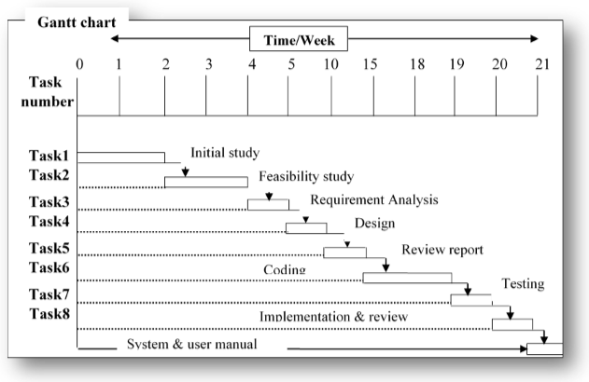**Figure 2.3: Gantt chart**

**2.10 Objectives/Goals of the System**

The major goal for e-second book shop is that in future people, especially students should have an easy way to buy and sell second hand books in online. The users will be able to carry out all these in a secured and managed environment. The secondhand-eBook shop shall be easy to navigate and user friendly and easy to find books in various categories. It shall be easy to administer and handling of orders and sales processes shall be easy to handle by the administrator.

* Provide a way to buy cheaper books online
* Provide a better way to recycle text books.
* Users will be able to make money for themselves by selling secondhand-books.
* A User friendly secondhand e-bookshop.

**2.11 Testing**

Software testing is an investigation conducted to provide stakeholders with information about the quality of the product or service under test. Software testing can also provide an objective, independent view of the software to allow the business to appreciate and understand the risks of software implementation.

Software testing can be stated as the process of validating and verifying that a software application:

1. meets the requirements that guided its design and development;

2. Works as expected, and

3. Can be implemented with the same characteristics.

The techniques for testing application are given below:

* Unit testing
* Black box testing
* Functional testing

**Unit Testing**

This is a procedure of testing individual code modules before they incorporated with different modules. Unit testing being tried might be a capacity, subroutine, technique or strategy. Units might be generally little gatherings of interrelated modules that are constantly executed as a gathering. The objective of unit testing is to recognize and fixed however many mistakes as would be prudent before modules are consolidated into a bigger programming unit. Mistakes become substantially more troublesome and costly to find and fixed when numerous modules are joined. Unit testing of **Online Second Hand Book Shop** are given below:

**Unit Testing 1:** Login as user

**Testing Object:** To ensure user can login into system correctly with valid user email and password.

|  |  |  |  |  |
| --- | --- | --- | --- | --- |
| **ID** | **Test case** | **Attributes and values** | **Expected Result** | **Result** |
| 1. | Login=“email id” Password=”123” | Non register user can login | The system will not allow non Registered user to login. | Pass |
| 2. | Login=“email id” Password=”123” | Wrong email and password | The system throws an error Prevent from login. | Pass |
| 3. | Login=“email id” Password=”123” | Enter correct email and password | The system can redirect to the page. | Pass |

**Functional Testing**

Feasibility Testing is characterized as a kind of testing which confirms that each capacity of the product application works in conformance with the prerequisite determination.

This testing fundamentally includes discovery testing and it isn't worried about the source code of the application. Functional testing of **Online Second Hand Book Shop** is given below:

**Functional testing:** Login with different user role.

**Testing Object:** To ensure user with different role login according to restricted System features.

|  |  |  |  |  |
| --- | --- | --- | --- | --- |
| **ID** | **Test case** | **Attributes and values** | **Expected Result** | **Result** |
| 1. | Login as “Admin” | Login with admin Information. | Successfully Login. | Pass |
| 2. | Login as “Seller” | Login with seller Information. | Successfully Login. | Pass |
| 3. | Login as “customer” | Login with customer Information. | Successfully Login. | Pass |

**Black Box Testing**

Internal system design is not considered in this type of testing. Tests are based on requirements and functionality.

Black box testing of **Online Second Hand Book Shop** is given below:

|  |  |  |  |  |
| --- | --- | --- | --- | --- |
| **ID** | **Test case** | **Expected Result** | **Real Outcome** | **Result** |
| 1. | Login=“email id” Password=”123” | Login | Not login. | Fail |
| 2. | Login=“email id” Password=”234” | Login | Login | Pass |
| 3. | Login=“email id” Password=”456” | Login | Login | Pass |

CHAPTER 3

**SYSTEM ANALYSIS**

**Online Second Hand Book Shop** is a web based project. We tried to focus on have an easy way to buy and sell second hand books in online. The users will be able to carry out all these in a secured and managed environment. The secondhand-eBook shop shall be easy to navigate and user friendly and easy to find books in various categories. It shall be easy to administer and handling of orders and sales processes shall be easy to handle by the administrator. Provide a way to buy cheaper books online Provide a better way to recycle text books. Users will be able to make money for themselves by selling secondhand-books. A User friendly second hand e-bookshop.

**3.1 Proposed Methodology**

For the website to fulfill its functionality three users are required for a successful purchase process to take place. The methodology used in this project is given below:

1. Sanjida(user one) creates an account because he wants to buy a book.

2. Shawon(user two) creates an account because she wants to sell a book

3. Shawon uploads a books

4. The book appears at the websites home page directly based on its category.

5. Sanjida fills his profile so that he can easily buy books.

6. Sanjida has seen the book he wanted to buy. The book was uploaded by Shawon (user two). He clicks on the book and goes through the checkout process. He buys the book.

7. Shawon gets a mail that her book has been bought. She sends the book to Sanjida’s address.

8. Sanjida tells the administrator of the website that he has gotten the book. The administrator credits Sanjida’s account.

9. The Administrator (power user three) He/ She can handle all over the website

10. John can give a feedback about the book he bought from Mary.

**3.2 System overview of Online Second Hand Book Shop**

System overview of Online Second Hand Book Shop refers to the whole process where data will be sent to the web server and received to database device. We have used the XML as the communication bridge between web services and web server. The overall process is illustrated in the figure below:

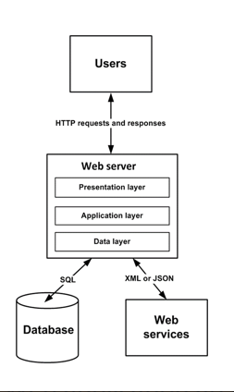

**Figure 3.1: System Overview of Online Second Hand Book Shop**

According to the figure 3.1 in time of data sending first web server which will be generate from HTTP post request towards PHP. Then PHP will make a request to the web server and PHP receive the result from the server. The result will be converted into a XML and the XML will be given to the web Services and save into local SQL database. Thus, the data flow process will be occurred due to any valid request.

**3.2.1 Data overview**

We tried to represent all of the data in an efficient way. In **Online Second Hand Book Shop**, list views are used very frequently. So, it is very important to represent list view items in a magnificent way. In web based, list views are controlled by the web server.

**3.3 Security**

**Online Second Hand Book Shop** will create a secure communication between the web servers. HTTP session management is the core of web security. When web server received request from the website, then the server provide the data in XML format. All mitigations should be adopted to make sure sessions are secured. Developers should also enable/use applicable security measures.

**3.4 Version support**

As a web based platform, **Online Second Hand Book Shop** must be supported on most of the browsers. It must be supported by all possible and most usable browsers like Google Chrome, Mozilla Firefox and etc.

**3.5 System Design**

System design is the process of creating alternative solution to satisfy the study goals, evaluation the choices and the drawing up the specifications for the chosen alternative.

**Objective:** Transformation of the system specification into and operational system design.

**Input:** Project goals, user requirement priorities, specification.

**Process:** Transformation often with several alternatives whose costs and benefits must be qualified and compared.

**Output:** Logical system design, production schedule, software and hardware requirements.

**3.6 A general Model of software design process**

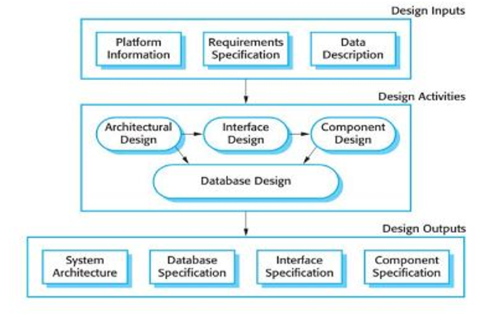

**Figure 3.2: A general Model of software design process**

**3.7 Flow Chart**

A flow chart is a graphical or symbolic representation of process. The flow chart symbols are linked together with arrows showing the process flow direction.

**3.7.1 Flow Chart for Admin**

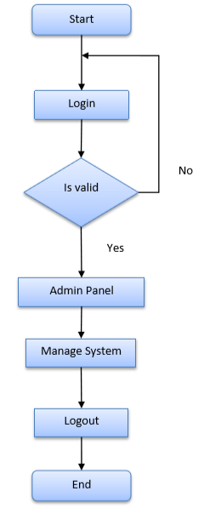

**Figure 3.3: Flow Chart for Admin**

**3.7.2 Flow Chart for Seller**

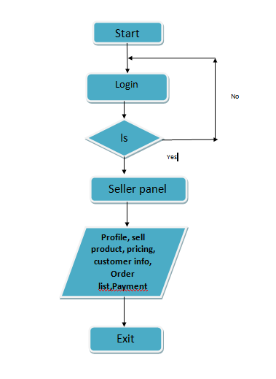

**Figure 3.4: Flow Chart for seller**

**3.7.3 Flow Chart for Customer**

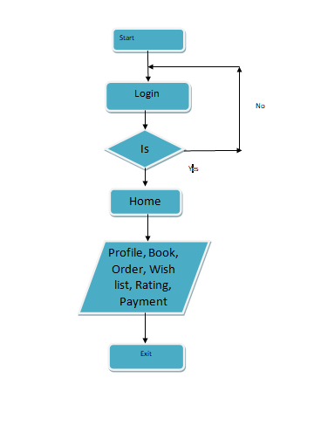

**Figure 3.5: Flow Chart for Customer**

**3.8 Use case Diagram**

A use case diagram is a graphic depiction of the interactions among the elements of a system. A use case is a methodology used in system analysis to identify, clarify, and organize system requirements.

**3.8.1 Use Case Diagram for Admin**

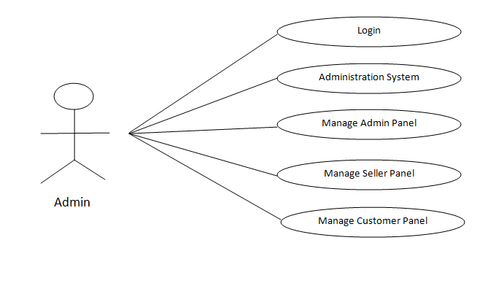**Figure 3.6: Use Case Diagram for Admin**

**3.8.2 Use Case Diagram for Seller**

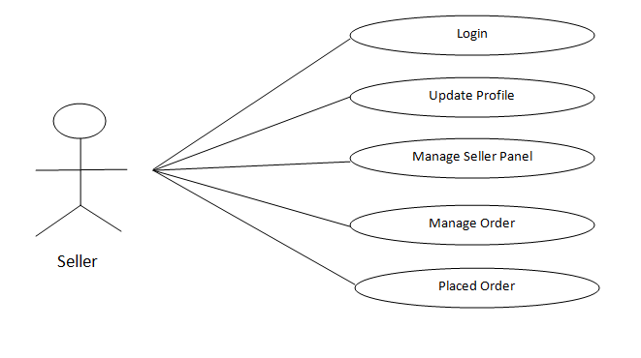

**Figure 3.7: Use Case Diagram for Seller**

**3.8.3 Use Case Diagram for Customer**

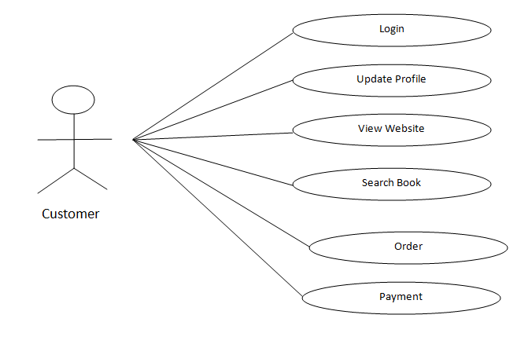

**Figure 3.8: Use Case Diagram for Customer**

**3.9 Entity Relationship Diagram of Online Second Hand Book Shop**

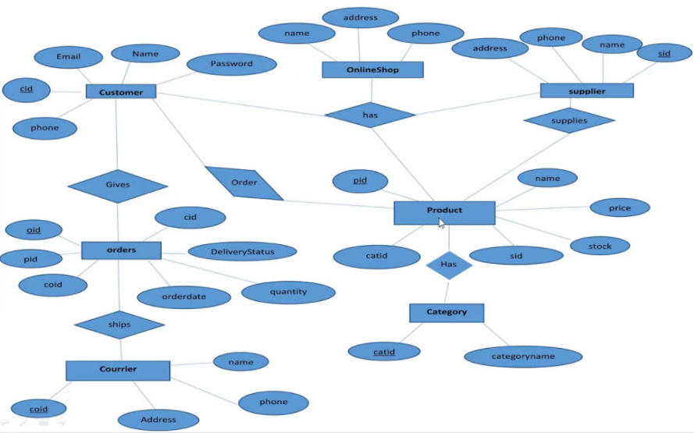

**Figure 3.9: ER Diagram for Online Second Hand Book Shopping**

**3.10 Database Table of Online Exam Management System**

In order to fully utilize MySQL server innovation, it is fundamental to ensure that the database is very much structured. The documents names picked to mark every one of the tables made inside the database endeavor to mirror the table's motivation and, in this way, add to well plan framework. The in time step in structuring was to choose, as indicated by the necessities and particulars of the venture, which tables ought to be made, and what kind of data everyone should hold.

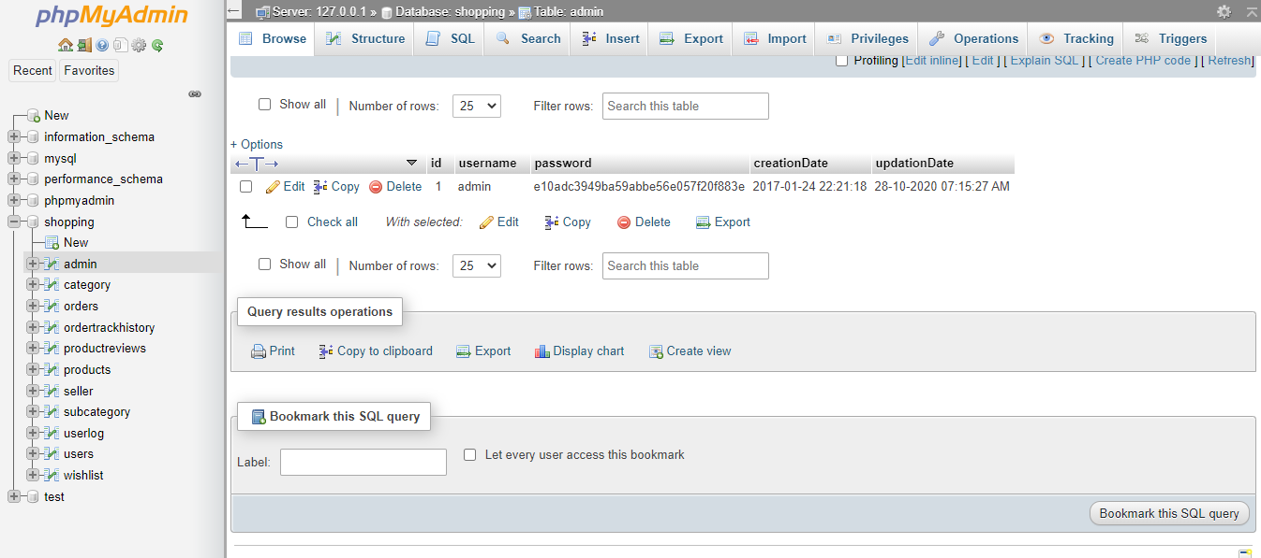

**Figure 3.10: Database table of Admin**

* In admin table id is primary key.

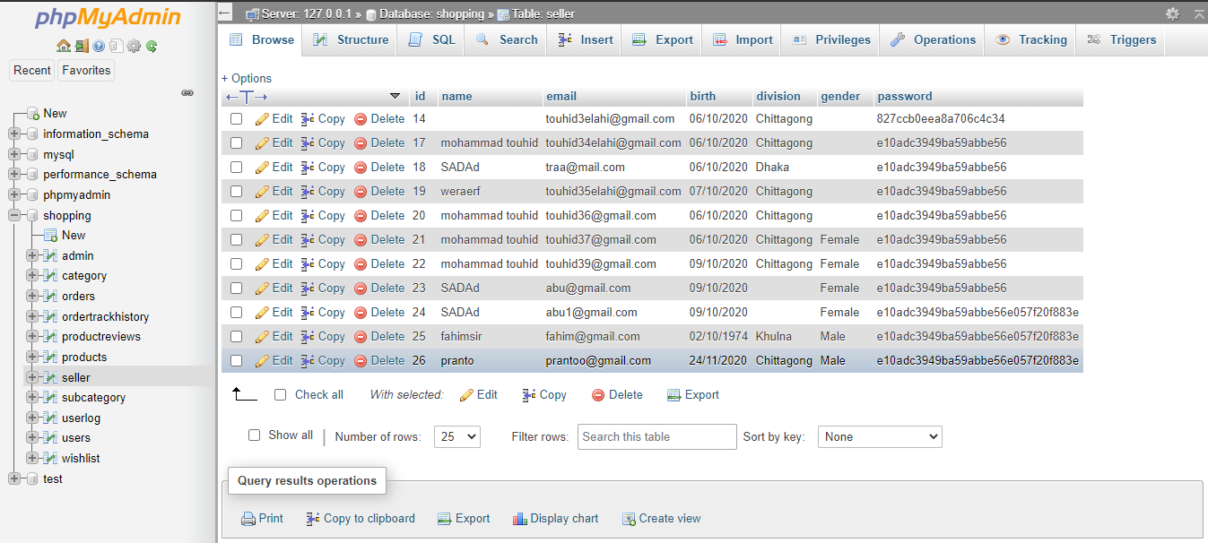

**Figure 3.11: Database table of Seller**

* In Seller table id is primary key.

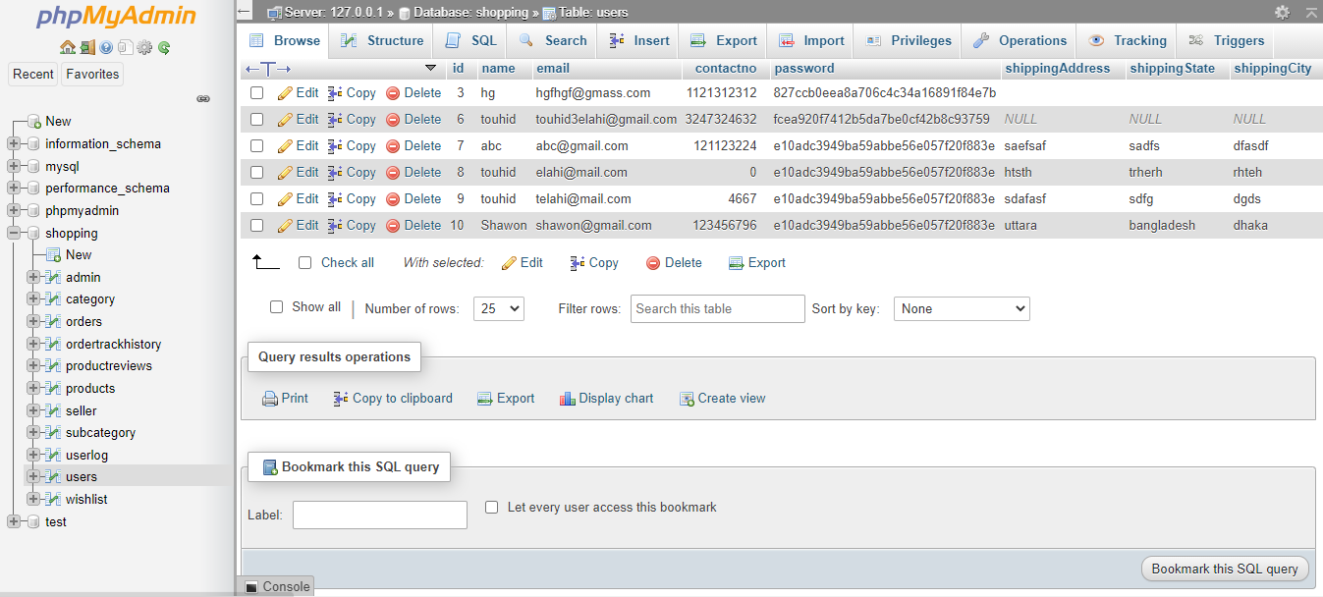

**Figure 3.12: Database table of Customer**

* In Customer table id is primary key.

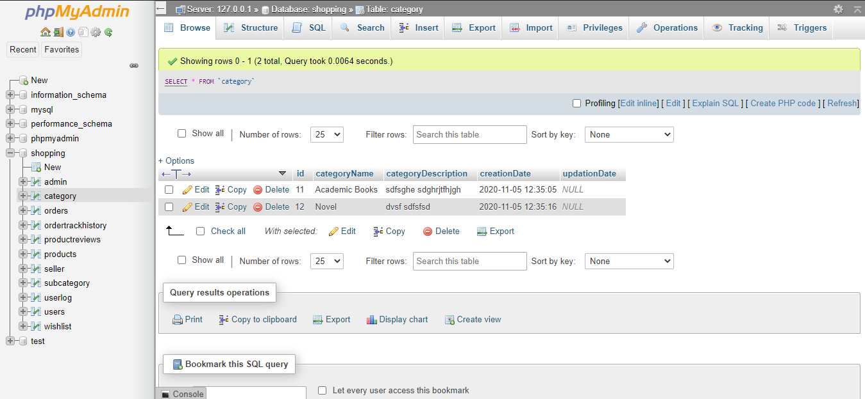

**Figure 3.13: Database table of Book Category**

* In Category table id is primary key.

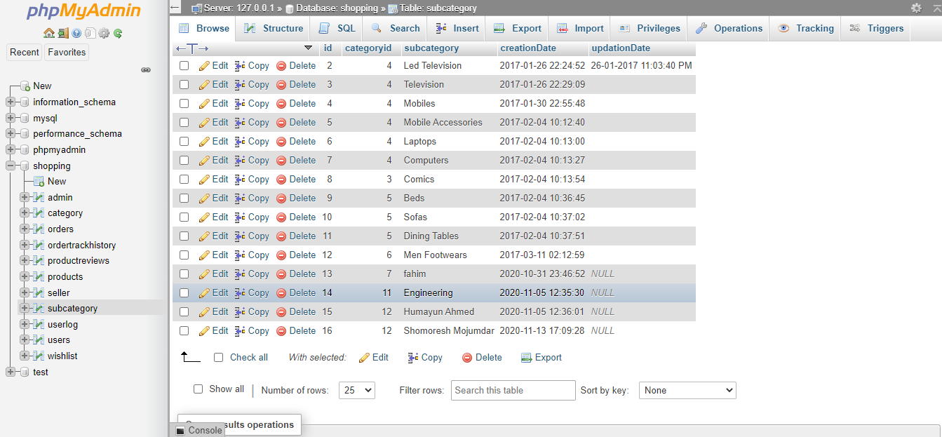

**Figure 3.14: Database table of Subcategory**

* In subcategory table id is primary key.

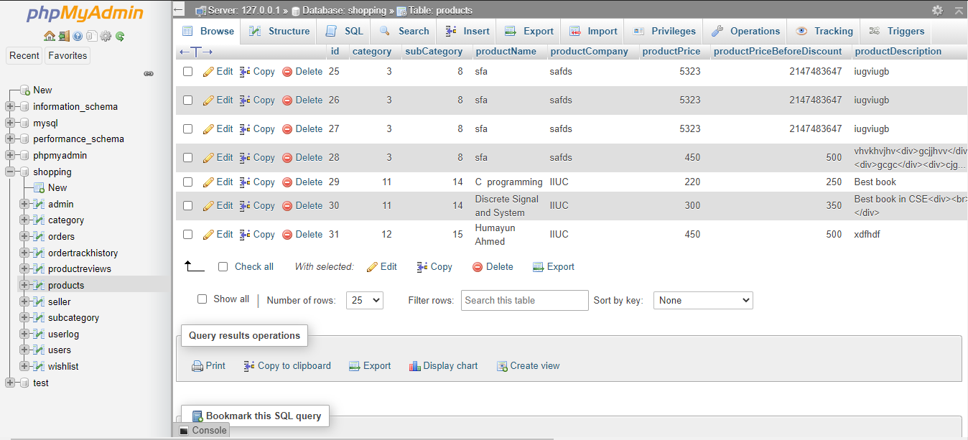

**Figure 3.15: Database table of Book**

* In Book table id is primary key.

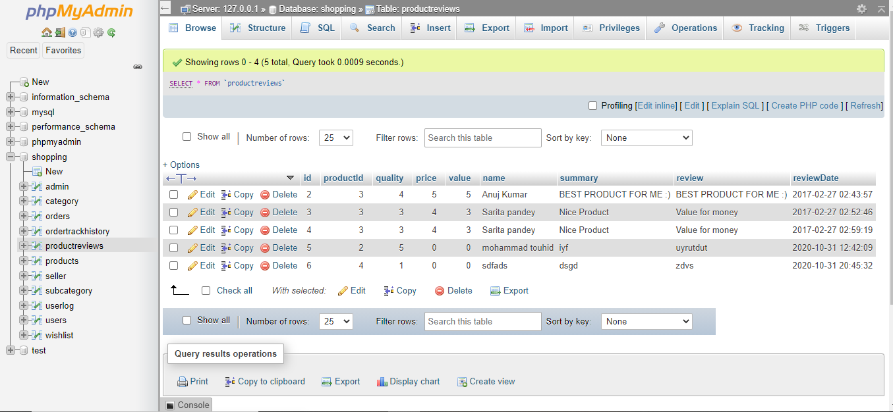

**Figure 3.16: Database table of Book Review**

* In Book Review table id is primary key.

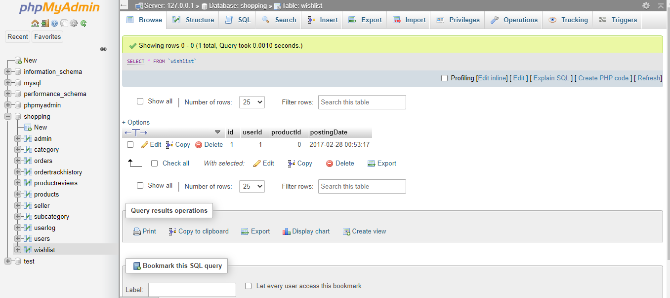

**Figure 3.17: Database table of Wish list**

* In Book table id is primary key.

**3.11 Data flow Diagram**

A data flow diagram (or DFD) is a graphical representation of the flow of data through an information system. It shows how information is input to and output. From the system, the sources and destinations of that information, and where that Information is stored.

**3.11.1 Level 0 DFD**

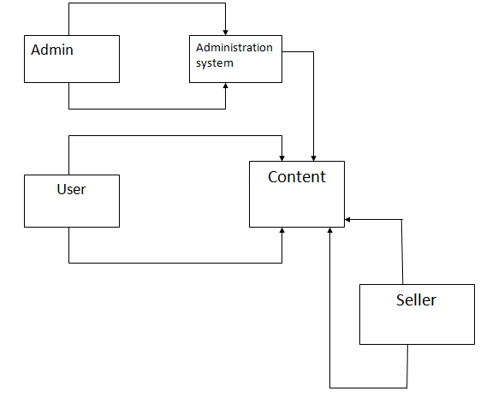

**Figure 3.18: Level 0 DFD for Second Hand Online Book**

**3.11.2 Level 1 DFD for Admin**

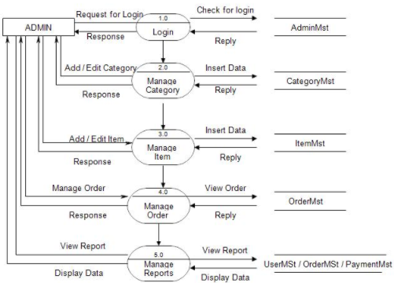

**Figure 3.19: Level 1 DFD for Admin**

**3.11.3 Level 1 DFD for Seller**

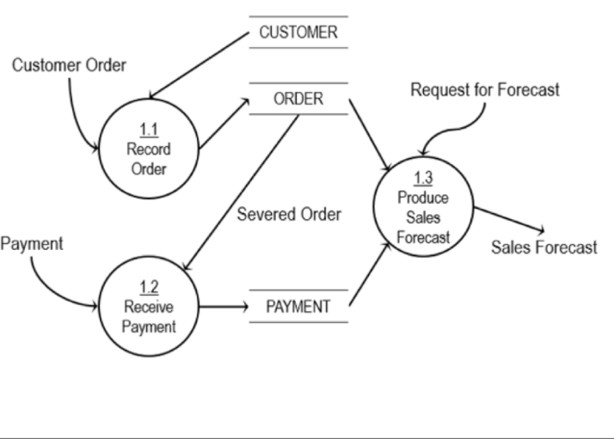

**Figure 3.20: Level 1 DFD for Seller**

**3.11.4 Level 1 DFD for Customer**

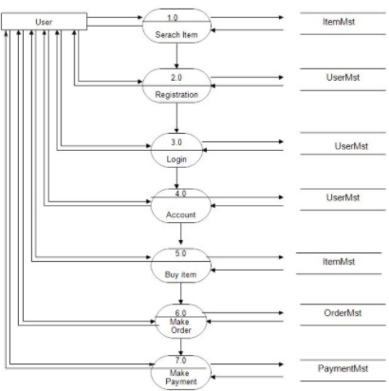

**Figure 3.21: Level 0 DFD for Customer**

**3.12 Activity diagram**

Activity diagram is another important factor in UML to describe dynamic aspects of the system Activity diagram is basically a flow chat to represent the flow from one activity to another activity. The activity can be described as an operation of the system. Activity is a particular operation of the system. Activity diagrams are not only used for visualizing dynamic nature of a system but they also used to reverse engineering technique. The only missing thing in activity diagram is the message part. It does not show any message flow from one activity to another activity diagram is some time considered as the flow chat. Although the diagrams looks like a flow chat but it is not, it shows different flow like parallel, branched, concurrent and single.   
So, the purposes can be described as:

* Draw the activity flow of a system.
* Describe the sequence from one activity to another.
* Modeling business requirements.
* Describe the parallel, branched and the concurrent flow of system
* Modeling work flow by using activities.
* High level understanding of the system's functionalities.

**3.12.1 Activity Diagram of Admin**

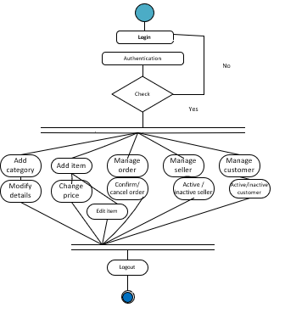

**Figure 3.22: Admin Activity Diagram**

**3.12.2 Activity Diagram of Seller**

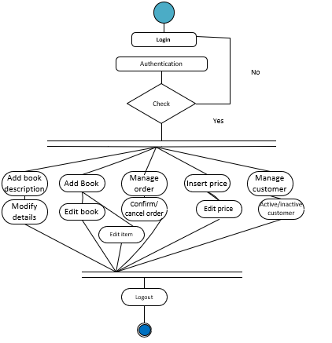

**Figure 3.23: Seller Activity Diagram**

**3.12.3 Activity Diagram of Customer**

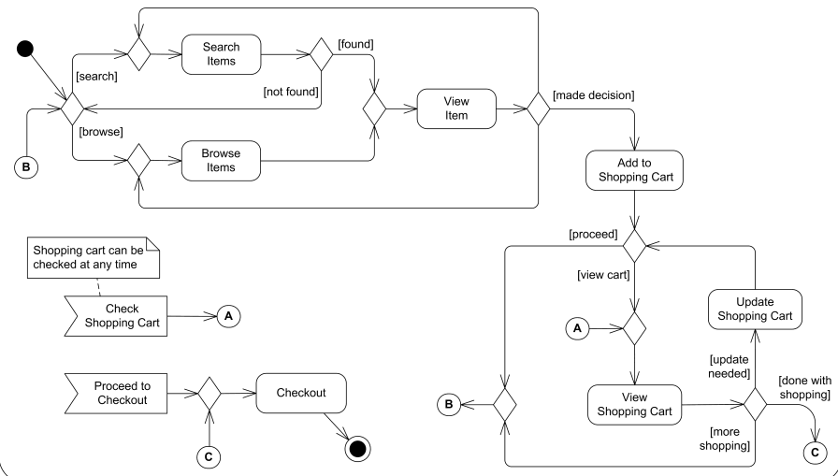

**Figure 3.24: Customer Activity Diagram**

CHAPTER 4

**DESIGN AND IPLEMENTATION**

**4.1 Overview**

In this chapter, we have provided the experimental result analysis of our developed system for web. We have provided snapshots of every step that an admin, Seller and a customer can go through.

**4.2 Design Model**

A design model in Software Engineering is an item based picture or pictures that speak to the utilization cases for a framework. Or on the other hand to put it another way, it is the way to depict a framework's execution and source code in a diagrammatic manner.

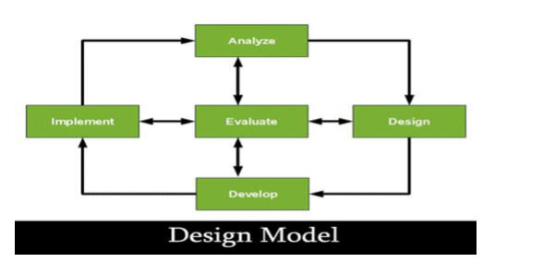

**Figure 4.1 Design Model**

**4.3 Graphical Representation**

The obtained results for both web showed in the next sections.

**4.3.1 Web Application**

**Online Second Hand Book Shop** starts with one more splash screen that exists for few seconds and then proceeds to terminal. User can easily login and navigate to the various feature of the website.

* **Customer Panel**

**Home Page:**

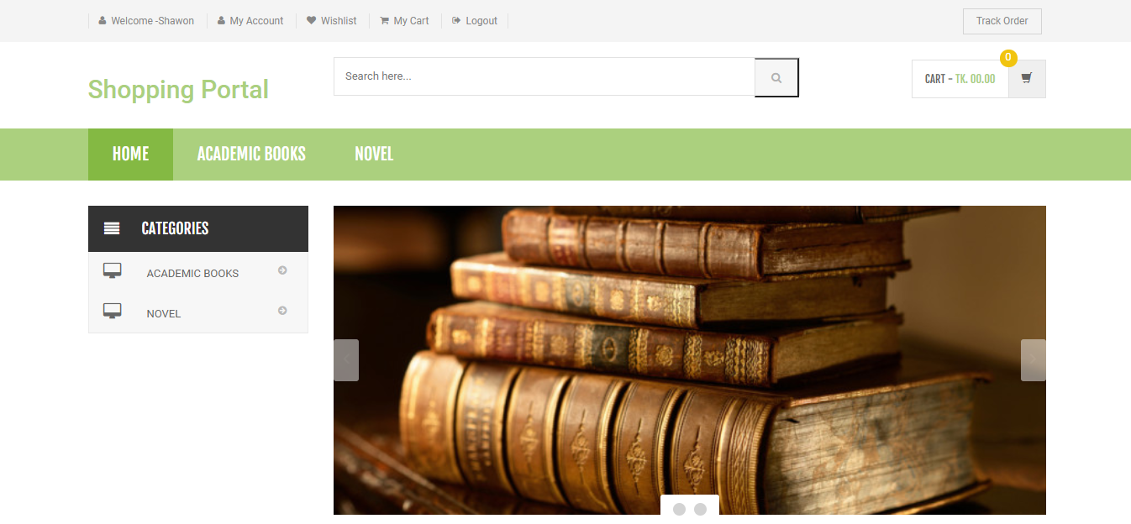

**Figure 4.2: Homepage Screen of website**

* This (a) is the homepage of our website.
* Here Customer can see the Book and Book details.

**Book Category:**

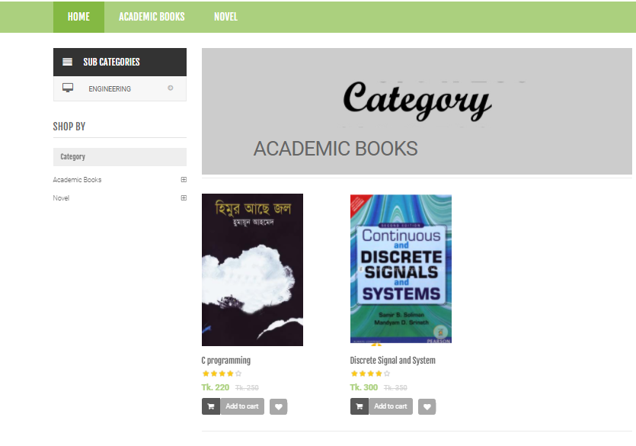

**Figure 4.3: Book Category and Book details of website**

* All the book is category wise arranged.
* Show Book Details.

**Customer gives rating:**

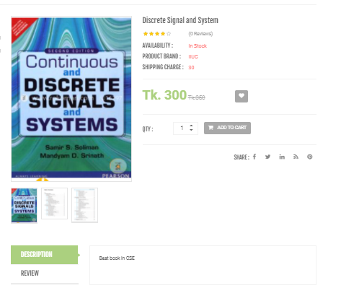

**Figure 4.4: Customer Rating System**

* Customer give rating of this book
* Before purchase the book customer read the few pages of the book.

**Customer wish list:**

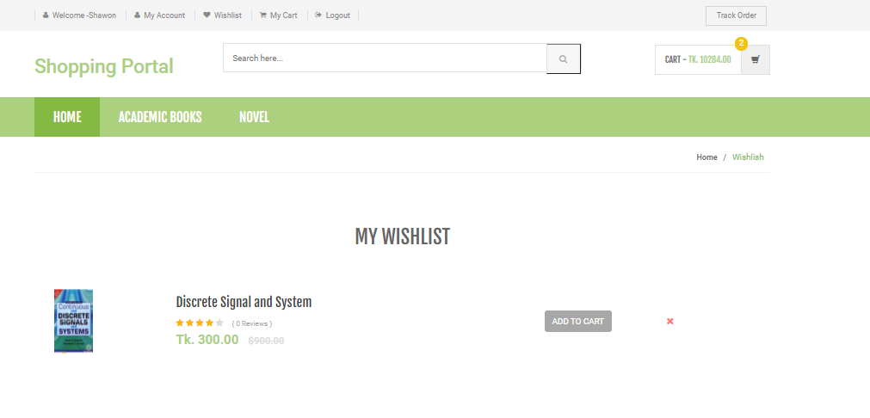

**Figure 4.5: Customer wish list**

* Customer has the wish list.
* If Customer like any book than customer click the wish button then it can stored customer wish list in customer profile.

**Customer login:**

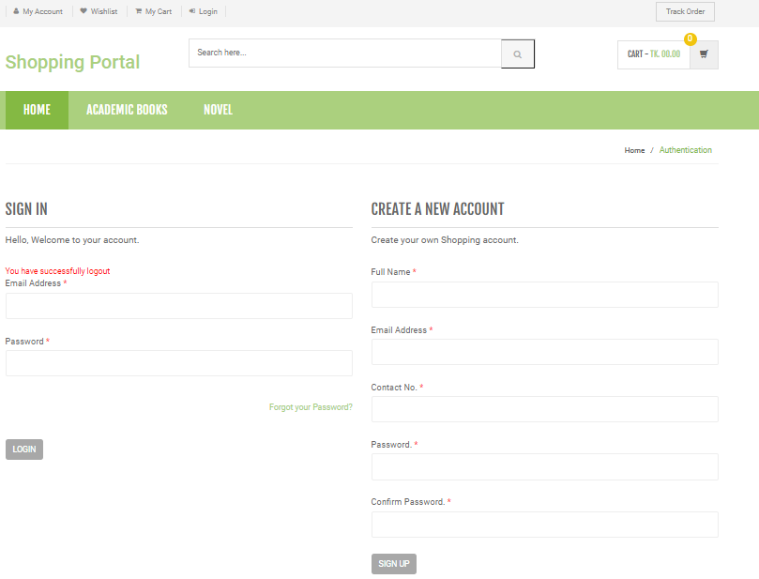

**Figure 4.6: Customer login of website**

* Customer login page.
* Before purchase book Customer create account of the website

**Customer making order:**

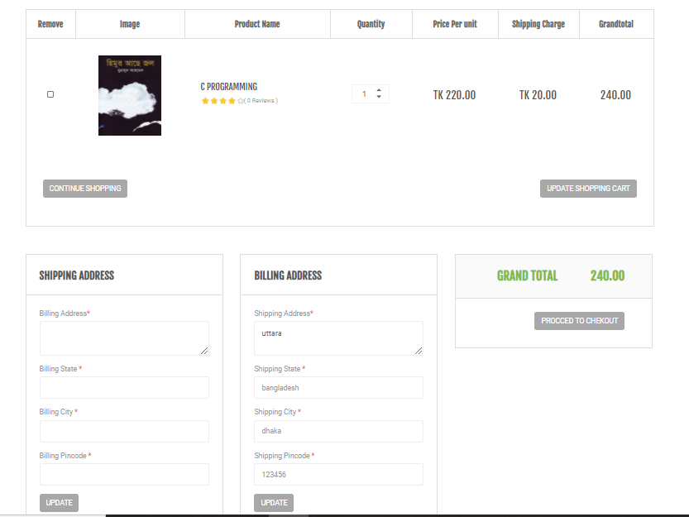

**Figure 4.7: customer Order panel of website**

* Customer ordering book.
* Before purchase book fill up the shipping and billing address.

**Payment System:**

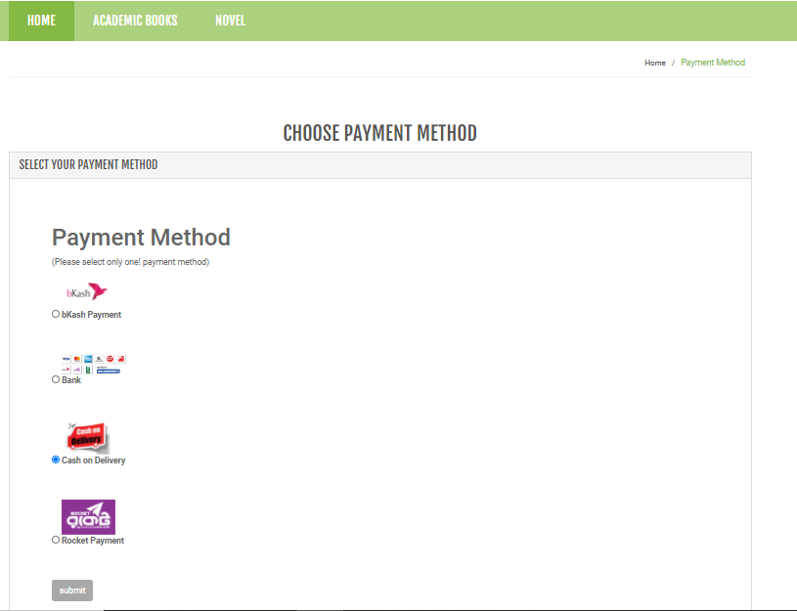

**Figure 4.8: payment system of website**

* Customer payment in much way.
* Payment system is very easy to pay.
* **Admin panel**

**Admin login panel:**

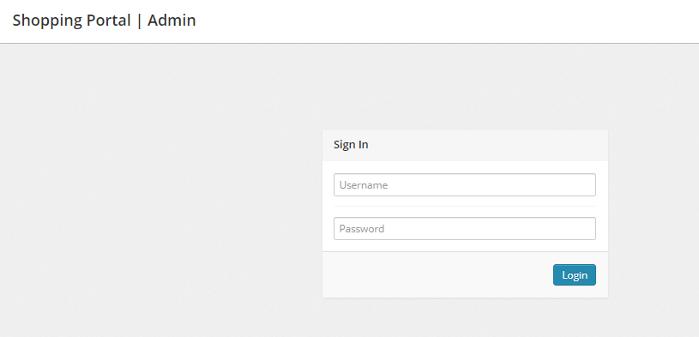

**Figure 4.9: Admin login panel of website**

* Admin can view the entire panel, manage all panel.
* Admin can change, delete anything.

**Admin Panel:**

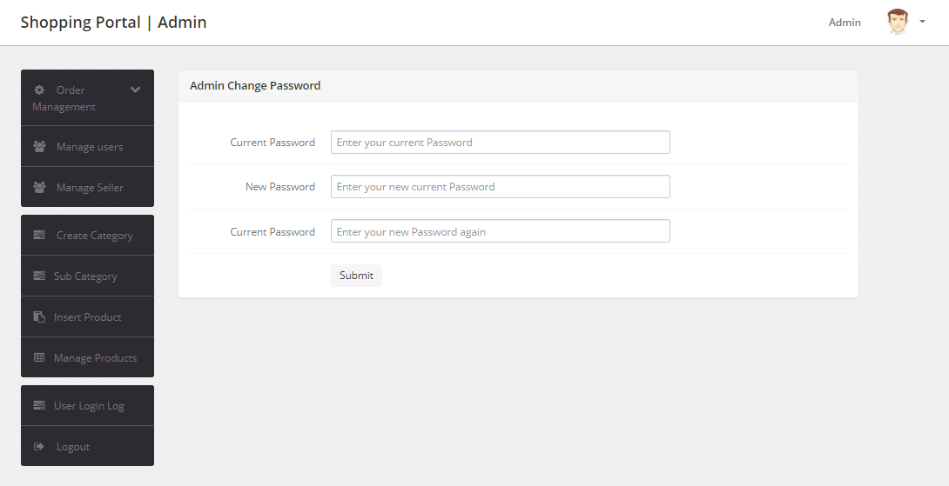

**Figure 4.10: Admin panel of website**

* Admin can view the entire panel, manage all panel.
* Admin can change, delete anything.

**Admin manage product (Book) :**

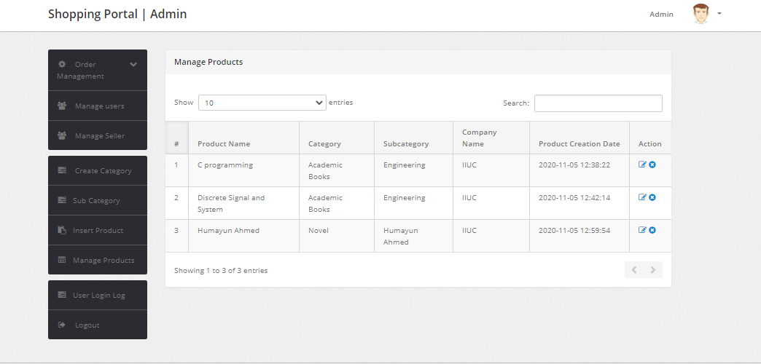

**Figure 4.11: Manage book or product by Admin**

* Admin can delete book, insert book.
* Admin can change, delete anything.

**Admin Insert book:**

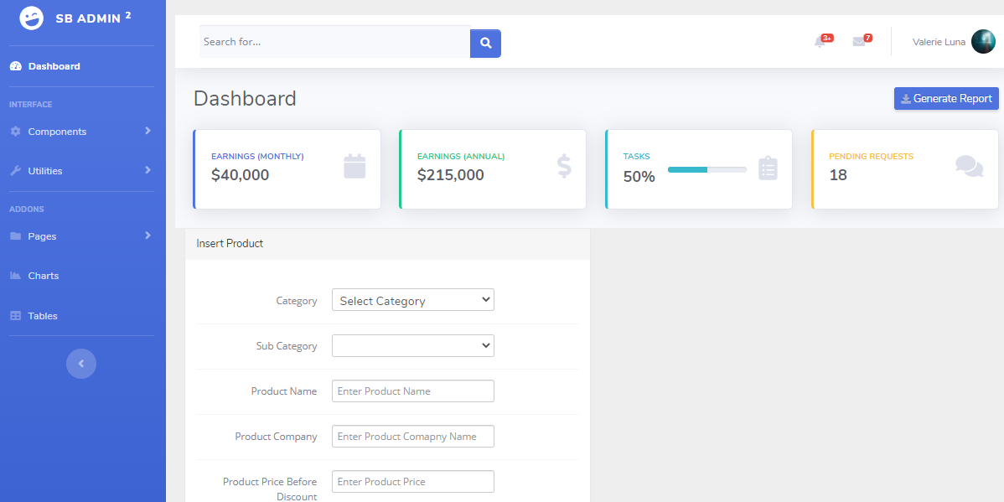

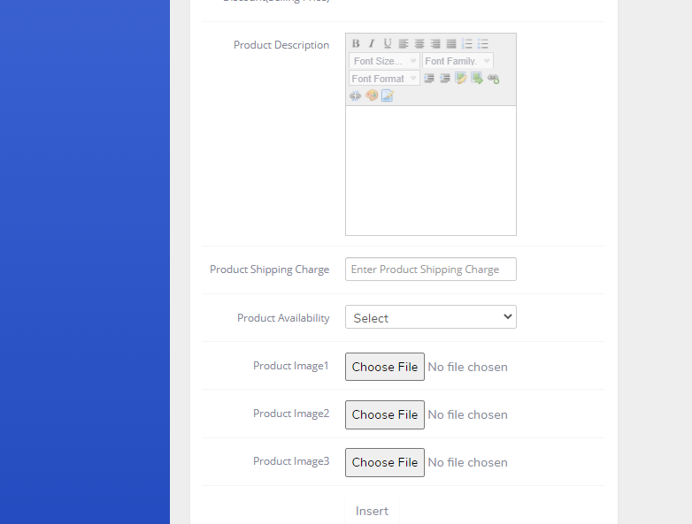

**Figure 4.12: Admin insert book**

* Admin insert the book.
* Admin can change, delete anything.

**Admin manage seller:**

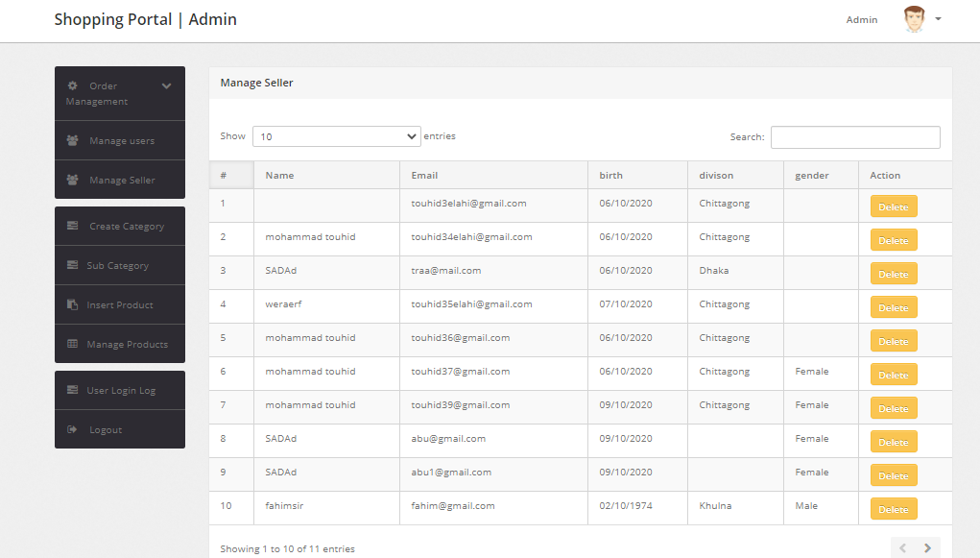

**Figure 4.13: Manage seller by Admin**

* Admin can delete any seller.
* Admin can change, delete anything.

**Admin manage user:**

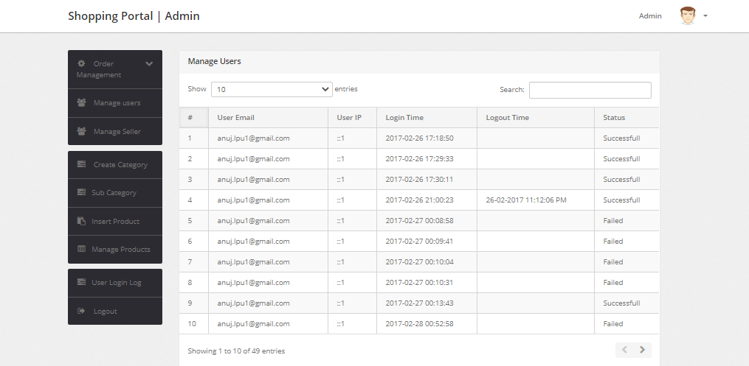

**Figure 4.14: Admin manage user**

* Admin can delete any customer.
* Admin can observe customer activity.
* Admin can change, delete anything.
* **Seller Panel**

**Seller register panel:**

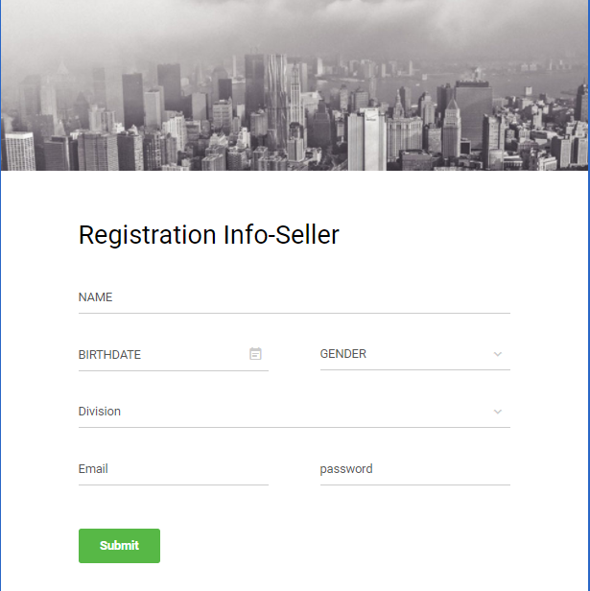

**Figure 4.15: Seller register panel**

* Seller registers the panel.
* Seller can sell the product but firstly register the website.

**Seller login panel:**

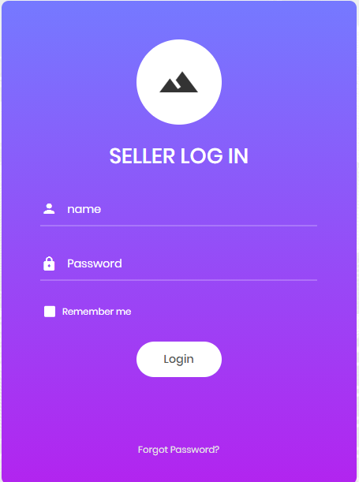

**Figure 4.16: Seller login panel**

* Seller login the panel.
* If Seller register the before than seller use only login page.

**Seller panel:**

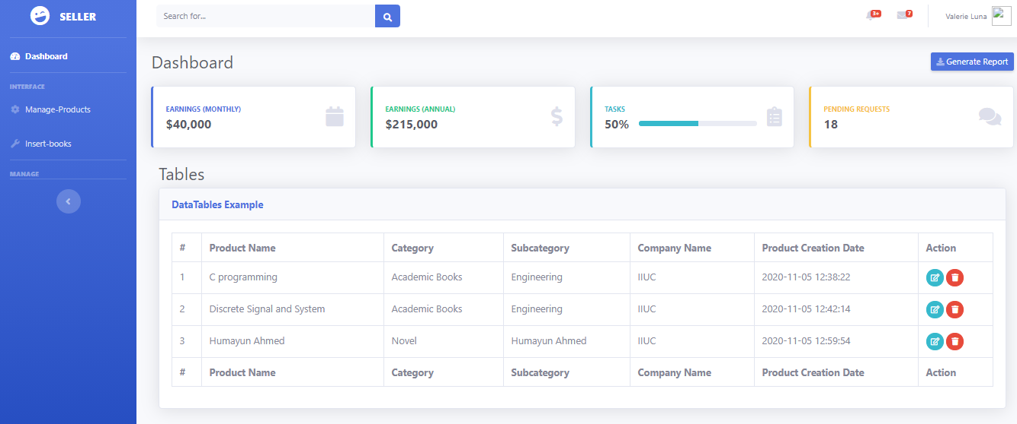

**Figure 4.17: Seller panel**

* Seller can manage panel.
* Seller delete, insert only seller book.

**Seller insert book:**

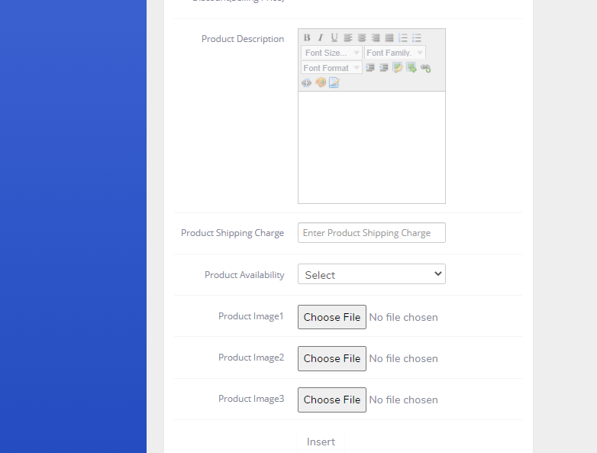

**Figure 4.18: Seller Insert Book**

* Seller can insert the book for selling.
* Seller delete, insert only seller book.

CHAPTER 5

**CONCLUSION**

**5.1 Limitations**

* User can’t edit/delete info.
* This is not real time based.
* Internet connection will need for use this app & update database.

**5.2 Future work**

* Add a screening mechanism to the website when uploading books. Control the prices, images and book names before loading it to the main page of the website .
* Add more payment gateways
* Addition of themes
* Possibility to save orders and confirming it later
* Reservation of books
* Add forums and videos
* Access the applications on a mobile phone and reserve books
* Add E-Book formats like PDF and others in the selling portal
* Add a preview page after adding books.
* Greater user experience
* Multilayer architecture with separation on concerns
* Possibility for the buyer to bargain

**5.3 Conclusion**

My goal was to create an application where people will upload books and be able to sell them online. The current application has fulfilled these goals. I followed the specifications strictly but enhanced some of the features when there was need for it to be done. With the goals achieved the basis of the application and this project has been achieved. Building this web application has been challenging and enriching because throughout the project I learnt a lot about .Net and understand what it takes to build an E-commerce store. There have been challenges especially when it came to the payment gateway and making sure that the application responses in a predictable. Careful planning made my job easier because I had to carefully think about the type of architecture, the design, the database types to use and what type of business objects to create. When this was done I proceeded with implementation. Choosing the .Net framework for this project made the project to be realizable in that amount of time because the framework handled most of the heavy burden in underlying connections, security, portability and functionality. I could focus on the creation of the application and hence in this amount of time could develop a complete online shopping cart and membership site. As I came to the end of the project I realized that they are many enhancement that can be made on the application .Some of these ideas came from those who tested the application and some of them from me. I decided to follow the specification because there were realistic to achieve in this given amount of time. Any other enhancements to the application can be done in future development of the application.

References

[1] A. Dennis, B. H.Wixom, “System Analysis and Design”, 2000.

[2] A. Silberchatz, H F. Korth, S. Sudarsham, “Database System Concept”, 4th

Edition, the McGraw-Hill Companies, NY, USA, 2002.

[3] D.Griffiths and D. Griffiths : Head First Android Development, 2nd Edition

[4] Silberschatz, Korth, Sudarshan ,Database System Concepts, 5th Edition

[5] I. Sommerville, “Software Engineering”, 7th Edition, Pearson Education, 2004.

[6] R.S. Pressman,“Software Engineering – A Practitioner’s Approach”, 5th Edition, McGraw-Hill International Edition, 2001.

[7] Award, E.M. Award, “System Analysis and Design”, 2nd Edition, Richard D. Irwin, Inc, 2000.

[8] Sanderson D. (2010): Programming Google App Engine, 1st Ed. O‟Reilly Media, Inc., USA.

[9] <http://www.w3schools.com/html/defualt.asp>

[10] <http://www.w3schools.com/css/default.asp>

[11] <http://www.w3schools.com/js/default.asp>